The problem is in the constructor; we have a not safe publication.
Because we pass this in the parameter of the method, but this is dangerous, because when we use this in the constructor our object can be created by more than one thread and so this can reference to multiple thread’s creation call. Constructor is a dangerous zone in fact this is not completely defined.
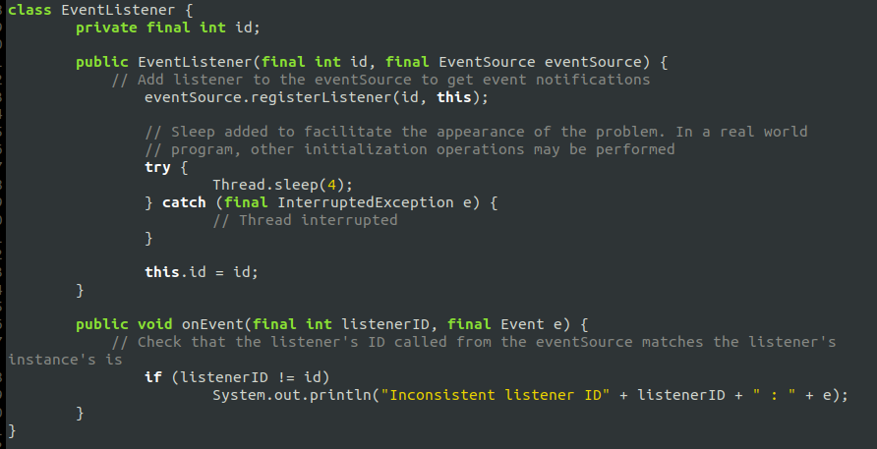
We can fix this using a method that update listeners list that use this parameter, but in this case the refernce is defined for the object that call method. We call this method after the the addiction to the list of the EventListener and so the creation of the object.
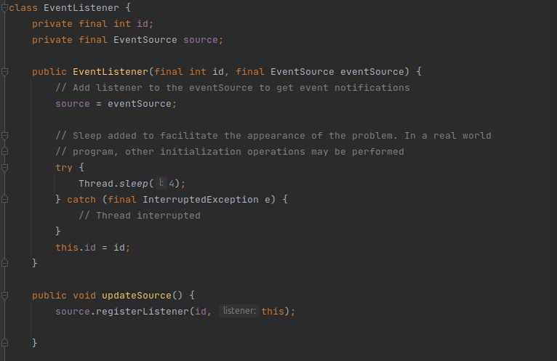
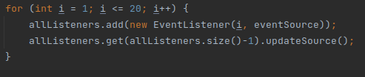
Under the method call

